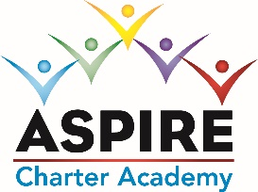
ASPIRE CHARTER ACADEMY BOARD MEETING MINUTES
DATE: June 2, 2022
MINUTES
Meeting Called By | Tom Durkee
Type of Meeting | Board Meeting via Zoom
Facilitator
Start Time | 5:00pm by Zoom
Attendees | Tom Durkee, Dave Herbster, Elaine Fitzgerald; Sharon Owen, Shanda Fox, George Miarecki, Pam Schenkel
Absent
Approval of Minutes | Tom made a motion to approve the previous Board minutes and Elaine seconded the motion. The minutes were approved.

Discussion: Low Enrollment: Our enrollment sunk from 110 to 89. We have significant staff turn overs and resignations. Our Kindergarten and 1st grade have been at less than ½ of capacity. This year, we are planning to open 2 kindergarteners as they are returning in large numbers.

Discussion: Budget: George Miarecki went through this year’s proposed budget. Tom Durkee made a motion to accept the budget; it was seconded by Sharon Owen. The Board voted to accept.
Discussion: Should we pay bonus’ this year? The Board determined that we should NOT pay bonuses this year.
Discussion: Charisma Cyprian (Board Member) is unable to attend Board Meetings at this time.
Discussion: MH Plan: Aspire will adopt the OCPS Mental Health Plan. Tom Durkee made a motion to move forward and it was seconded by Sharon Owen. Tom Durkee will sign the required document which will be forwarded to the district.
Meeting adjourned at 7:00pm

