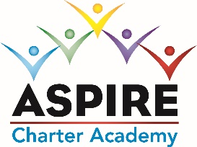
ASPIRE CHARTER ACADEMY BOARD MEETING MINUTES
DATE: February 23, 2023
MINUTES
Meeting Called By | Tom Durkee
Type of Meeting | Board Meeting via Zoom
Facilitator
Start Time | 5:00pm by Zoom
Attendees | Tom Durkee, Elaine Fitzgerald; Sharon Owen, Shanda Fox, Pam Schenkel
Absent | Charisma Cyprian, Dave Herbster
Approval of Minutes | Tom made a motion to approve the previous Board minutes and Elaine seconded the motion. The minutes were approved.

Discussion: Board Members: Charisma Cyprian has not attended a board meeting in over a year. She does not respond to phone calls or emails. Pam Schenkel asked the board to remove her from the position. The board agreed. That leaves 4 board members. With 3 members present, we have a quorum.

Discussion: Parent addressed the board and discussed her experience here at Aspire.
Discussion: We discussed the board approval of the safety policies we adopted from OCPS.
Discussion: Anticipated number of staff returning next year.
Discussion: Possible renewal of the lease with CRJ. Tom Durkee will call Michael Kancher to begin negotiations.
Meeting adjourned at 7:00pm

