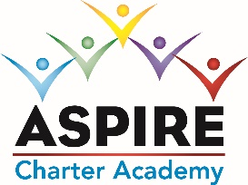
ASPIRE CHARTER ACADEMY BOARD MEETING MINUTES
DATE: July 25, 2023
MINUTES
Meeting Called By | Shanda Fox
Type of Meeting | Board Meeting via Zoom
Facilitator | Shanda Fox
Start Time | 6:00pm by Zoom
Attendees | Tom Durkee, Elaine Fitzgerald; Sharon Owen, Dave Herbster, Marjorie Moreland, Shanda Fox, Eugene Kendrick, George Miarecki
Absent | None
Approval of Minutes | Tom made a motion to approve the previous Board minutes and Elaine seconded the motion. The minutes were approved.

Discussion: Board Members: Charisma Cyprian has not attended a board meeting in over a year. She does not respond to phone calls or emails. Pam Schenkel asked the board to remove her from the position. The board agreed. That leaves 4 board members. With 3 members present, we have a quorum.
Discussion: Welcome Eugene Kendrick to the team!
Discussion: Introduce Prospective new board member Marjorie Moreland. Board unanimously voted her onto the board.
Discussion: Board voted to approve the 2023-24 Budget
Discussion: Board voted to approve Out of Field Teachers
Discussion: Three board members are up for their 5 Year Fingerprint renewal. They will work on their renewals this week.
Meeting adjourned at 6:30pm

